RESOLUTION NO.__________

RE: CERTIFICATE OF APPROPRIATENESS UNDER THE
PROVISIONS OF THE ACT OF THE PENNSYLVANIA
LEGISLATURE 1961, JUNE 13, P.L. 282 (53
SECTION 8004) AND BETHLEHEM ORDINANCE NO.
3952 AS AMENDED.

WHEREAS, it is proposed to install signs at 1 E. Third Street

NOW, THEREFORE, BE IT RESOLVED by the Council of the City of Bethlehem that a Certificate of Appropriateness is hereby granted for the work.

Sponsored by: (s)

(s)

ADOPTED BY COUNCIL THIS DAY OF

(s)
President of Council

ATTEST:

(s)
City Clerk

HISTORIC CONSERVATION COMMISSION

CASE # 628– It is proposed to install signs at 1 E. Third Street
OWNER/APPLICANT: Shale Road LP / Lin Shi

The Commission upon motion by Mr. Cornish seconded by Mr. Evans adopted the proposal that City Council issue a Certificate of Appropriateness for the proposed work described herein:
- The proposal to install signs at 1 E. Third Street was represented by Lin Shi.

- The blade sign will project a maximum of 36” from the façade including the sign bracket.

- The sign will be fabricated from ½” thick PVC sign material with a laminated aluminum sheet on both sides. Lettering and pinstripe border will be white vinyl applied to the burgundy aluminum sheet. The pinstripe broader should be approximately 3/8”-1/2” inset from the edge of the sign approximately 1/2” - 3/4”. The sign will read “SHANG WEI” with 4 Chinese characters.

- The sign will be approximately square in shape.

- The sign bracket must be mounted to the existing stucco band and not into the decorative terra cotta parapet.

- The sign will be located either on the 3rd St. side east of the storefront window, next to the entry or around the corner on New St.

- The storefront sign will be cut from 3/4” thick PVC laminated with a burgundy aluminum sheet. The letters will be mounted to the existing stucco sign band with 1/2” standoffs (min). The letters will be a maximum of 15” high

- The wall sign will not be illuminated or if illumination is desired it will be halo lit with lighting behind the lettering.

- The wall sign will read “SHANG WEI” with 2 Chinese characters.
- The motion to approve the proposed work was approved on a 5 to 1 vote. Mr. Traupman voted against due to confusion about approved location.

CU: cu
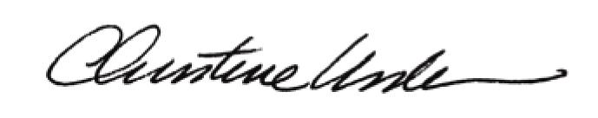

By:

Date of Meeting: October 16, 2017 Title: Historic Officer

